**Chapter 6**

**File and Hash Analysis**

**V1**

**SID: 2103022**

**Anglia Ruskin Final Project**

**Table of Contents**

**Introduction** 2

**Objective** 2

**1.0** **File Hash Export** 3

**2.0 Creating and using a Hash Set** 6

# **Introduction**

The sixth chapter covers file and hash analysis allowing an investigator to verify and validate digital data. This chapter aims to teach the reader how to firstly export file hash using FTK Imager and then create and use a hash set using Autopsy.

# **Objective**

* Export file has using FTK Imager
* Create and use a Hash Set using Autopsy.

1. **File Hash Export**

1.Login as Digital-Forensics and use the password **‘password’** to login to the VM.

2. Launch Magnet Process Capture found in the tools folder on the **Desktop. Desktop>Tools> FTK Imager**

3. Go **File>Add Evidence Item…**

4. Tick ‘Contents of a folder’ and click ‘Next’.

5. Click browse and locate the ‘FAKE DOCS’ folder from ‘**Desktop>Evidence>FAKE DOCS**’ then click ‘OK’ then ‘Finish’

6. Cick the plus symbol next to ‘FAKE DOCS’ and click ‘C:\Users\Digital…’ then you should see 5 images.



7. Click on the images to reveal what they are like the figure below

8. Right click on ‘C:\Users\Digital…’ then click ‘Export File Hash List…’.

9. Save the file as ‘CHAPTER 7 HASH LIST’ in the **‘Desktop>EVIDENCE>FILE HASH LIST’** folder

10. Locate the file you just saved and double click to open it.

11. Click ‘OK’.

12. You can now see the MD5 and SHA1 hash with the file location and name.

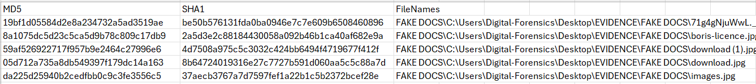

# **2.0 Creating and using a Hash Set**

1. Launch Magnet Process Capture found in the tools folder on the ‘**Desktop. Desktop>Tools> Autopsy’.**

2. Once loaded click ‘New Case’.

3. Name the Case name ‘Chapter 7’ and click browse to locate the Evidence folder on the Desktop then click next.

4. Fill in the boxes like the figure below and click ‘Finish’.

5. Wait for the loading bar to complete then click ‘Next’.

6. Select ‘Logical Files’ and then click ‘Next’

7. Click browse and locate the ‘HDD.E01’ file in the Evidence folder on the Desktop then click ‘Neext’.

8. Click Deselect all then tick ‘Hash Lookup’ like the figure below.

9.Click ‘Global Settings’.

10. Click ‘New Hash Set’.



11. Name it ‘Chapter 7 Hash’ and save the file path in the Evidence folder on the desktop.

12. Click ‘Add Hashes to Hash Set’.



13. Copy the MD5 hash from the OpenOffice Calc document we created earlier then click ‘OK’ and ‘Next’ then ‘Finish’.

14. Open the Chapter7 Hash section and compare the images with the hashes from before.

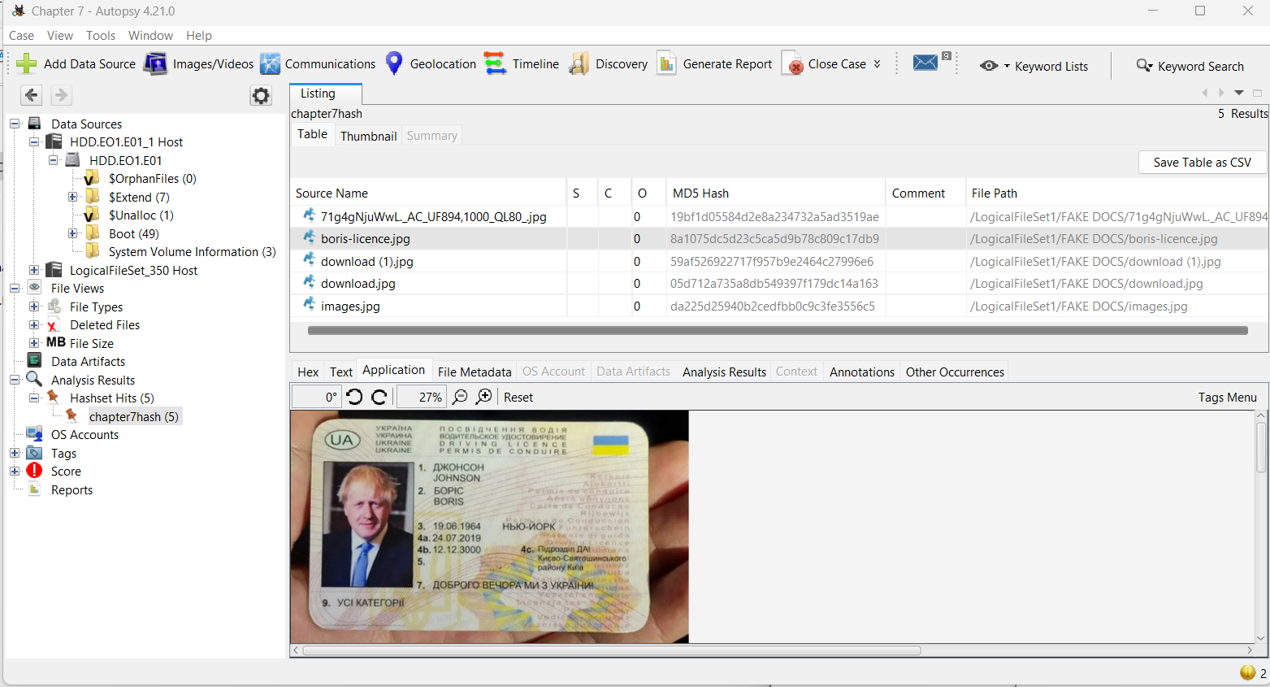

15. The chapter is complete, and you can now export a file hash list using FTK Imager as well as creating and using a hash set. You can close all applications and return to the desktop for Chapter 7 or shutdown if you wish to continue later.